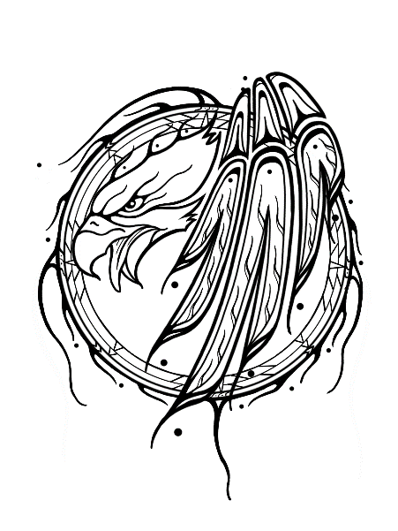Sturgeon Lake School

Postal Bag 5

Valleyview, AB T0H 3N0

 Phone: (780)-524-4590 Fax: (780)-524-3696

FNIYES

Summer Student Employment Program

2 weeks per group

**Applications are now being accepted**

SLCN is seeking summer students as part of the First Nations and Inuit Youth Employment Strategy (FNIYES) Summer Work Experience Program. These positions offer students work experience in areas such as administration, communications, community engagement, and program support. Students should be eager to learn, adaptable, and committed to teamwork and respectful workplace values.

**Who Can Apply?**

You are eligible if you:

* Are First Nations or Inuit
* Are between ages 15 to 30 years old
* A full-time secondary and/or a post-secondary student
* Live on-reserve
* Must have Social Insurance Card (SIN)
* Must have completed school year 2024-2025 and returning in September 2025 (This will be confirmed for eligibility)

Applications available at Sturgeon Lake School & Sturgeon Lake Band office

Deadline Friday, June 20, 2025 at 3:30 pm

Any questions please call the school 780-524-4590